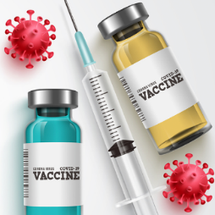 **Village of Hoffman Estates**

**Pediatric Covid Vaccine Clinic**

**FREE Pfizer Pediatric Covid Vaccine Clinic (Ages 5 – 11 years)**

The Village of Hoffman Estates is hosting a Pfizer Pediatric Covid Vaccine Clinic at Village Hall, 1900 Hassell Road, Hoffman Estates, IL 60169 (Main Entrance). Registration is available to anyone 5 through 11 years of age or older.

We are administering the first dose of the Pfizer Pediatric vaccine on Thursday, December 9 from 2:30 - 6 PM. Second dose appointments will be on Thursday, December 30, at the same time and place as your first dose. Please do not register if you are not available on both dates. Expect to stay for 15 - 30 minutes after the vaccine is given.

Registrations will be accepted on a first-come, first-served basis. Please note that appointments are required, and walk-up registration is not available. Telephone registration is not available for this vaccination event.

Please wear a short-sleeved shirt. Arrive no earlier than 15 minutes before your scheduled appointment.

Please bring the following to your appointment:

• Copy of identification such as birth certificate or vaccine record.

• Only children receiving a vaccine should attend with one parent or legal guardian.

Masks are required to be worn at all times during the clinic, and social distancing will be observed. Registrants will receive a confirmation of your vaccination appointment via email or text message.

Here is the link to Sign-Up for a vaccine.

<https://www.signupgenius.com/go/10C0F4AABA72DA3FAC43-pfizer>